A 501(c) (3) Non-Profit Organization

2013

The ISU BioBus Club Handbook
First Edition
R1.0
An Iowa State University Student Organization

“Everyone wants to make their mark. Everyone wants to leave their legacy. Let’s make ours -- brilliantly green, and permanent.”
-David Correll, ISU BioBus Club Founder, President

Table of Contents
INTRODUCTION 1
About ISU BioBus 1
History of BioBus 1
Our Mission 1
How BioBus helps 1
Biodiesel and its benefit 2
STRUCTURE OF CLUB 3
Responsibilities and duties 3
MEETING LOCATION 5
STRUCTURE OF MEETING 5
BUSINESS MEETING 5
Job descriptions (current officer) 5
Structure of Business Meetings 6
ENGINEERING MEETING 7
Job description (current officer) 7
Safety in the Lab 7
Structure of Engineering Meetings 9
FUTURE PLANS 11
DIRECTORY OF IMPORTANT CONTACT 12
APPENDIX 12

INTRODUCTION

About ISU BioBus
ISU BioBus is an interdisciplinary entrepreneurial student organization that recycles waste vegetable oil from ISU campus dining facilities to create usable biodiesel to fuel the city of Ames “CyRide” buses. BioBus utilizes the skills of many undergraduate and graduate students, including any major from chemistry and engineering, to business and supply chain management. BioBus members often have the opportunity to create real renewable energy and interact with campus and community members in BioBus’ various outreach events. BioBus offers members a unique perspective on renewable fuel production, engineering problem solving, and business management practices.

History of BioBus
Started in the fall of 2009 by David Correll, a PhD student in the College of Business focusing on supply chain management for biorenewable fuels, and Bernando del Campo, a PhD student in mechanical engineering focusing on renewable fuel production practices. They would meet for coffee and discuss strategies about how to make the program work and one day Cy visited them and with new found inspiration the program was started.

Our Mission
The main goal of BioBus is to promote and encourage campus sustainability, which we display through converting waste vegetable oil into usable energy. ISU BioBus has become an excellent way to provide Iowa State students with opportunities to participate in biodiesel research and production, while becoming acquainted with practical business and management skills. The primary goals for the ISU BioBus Club are centered around four key objectives: 1) to expose students and the community to experiential learning about sustainability, renewable fuels, and entrepreneurship, 2) to create a diverse community of students, industry, and faculty interested in advancing the bio-economy and the sustainability of our world, 3) to promote and maintain a healthy environment by reducing local and world pollution, and 4) to develop market-driven solutions to growing energy and environmental problems posed by industrialization and an increasing world population.

How BioBus helps
Currently, CyRide has designated one bus to run on BioBus produced biodiesel. Levels of production are low; BioBus presently produces about 40 gallons of B100 (100% biodiesel) each month. The current growth projection for BioBus is to produce two percent of CyRide’s fuel with future production growth reaching twenty percent.

Biodiesel and its benefit
Biodiesel is one of the major biofuels that is manufactured from biological ingredients such as vegetable oil, recycle oil or animal fat. The National Biodiesel Board (NBD) defines biodiesel as - a fuel comprised of mono-alkyl esters of long chain fatty acids derived from vegetable oils or animal fats, designated B100, and meeting the requirements of ASTM D 6751. It is made by the reaction of lipids and alcohol within the present of catalyst, which is called trans-esterfication. This reaction produces biodiesel and also glycerin as a co-product. Biodiesel is safe to be used in diesel engines without any modification. It can be used in its pure form, B100, or blended with normal diesel fuel and create different percentage concentrations such as B20.
Using biodiesel has lots of benefits as it is an environmental friendly energy source. Compared to normal diesel fuel, biodiesel produces reduced emissions of greenhouse gases and has positive energy balance. Biodiesel is also a renewable resource and nontoxic. For countries like United States, the production of biodiesel is important to the economy as it reduces the dependence on foreign oil. Using biodiesel reduces engine wear by increasing lubrication, improves public health, helps the environment, and provides safety benefits by virtue of lower toxicity.
Biodiesel is a non-toxic, biodegradable alternative to fossil fuels. This biofuel significantly reduces harmful emissions and can be used in virtually any diesel engine with no modifications.

STRUCTURE OF CLUB

This club has two organization positions; elected and appointed. The positions for elected are Director of Engineering and Operation (DEO), Lieutenant DEO, Director of Administration and Outreach (DAO), Lieutenant DAO, and also Treasurer. These positions are also known as Board of Directors. Some of the appointed positions under the engineering team are processing squad leader, collection engineering leader, process engineering leader and supply chain leader. As for the business team, the appointed positions are fundraising chair, partner and sponsor relation chair, campus event coordinator, educational outreach chair, and safety sultan. Figure 1 below helps to understand the structure of the organization better.
DEO
Lieutenant DAO
DAO
Lieutenant DEO
Treasure
- Processing squad leader(s)
- Collection engineering leader
- Process engineering leader
- Supply chain management leader

- Fundraising Chair
- Partner and sponsor relations chair
- Campus event coordinator
- Educational outreach Chair
- Safety Sultan

Figure 1 : BioBus organization structure
The Board of Directors (BOD) is elected to year-long term by majority vote during the election which is to be held in November. The time allotted for voting usually lasts for two weeks and the result is announced early December. The appointed positions can either be nominated by the BOD or others for duration of one academic year, or self-nominated.
Separation of the leadership into two areas of responsibility (engineering and business) aimed to ease the management of the club.

Responsibilities and duties

Responsibilities and duties of the officers are as follow, but not limited to (source from Constitution):

DAO
- Preside over meetings of the Executive Board.
- Preside over any general meetings ISU BioBus.
- Supervise normal internal operations of ISU BioBus.
- Coordinate and direct the activities of the operating committees.
- Such other responsibilities as authorized by ISU BioBus
- Purchase materials needed by ISU BioBus
Lieutenant DAO:
- Preside over business meetings and activities
- Plan outreach and promotional events
- Contact other officials within ISU and the surrounding community

DEO:
- Preside over engineering meetings and activities.
- Coordination of engineering/lab personal
- Responsible for fuel quality and lab safety
Lieutenant DEO:
- Responsible for fuel quality and lab safety
- Keep track of training records and approve people for lab entry
Treasurer
Treasurer needs to take the treasurer training via Blackboard. Once the training is completed, p-cards can be ordered.
- Validating p-card purchases and
- Scanning or uploading p-card receipts. The treasurer also responsible
- Turning in W-9s to the COA office
- Picking up monthly statements and voucher copies, and receipts from the organization’s folder in the Organization Accounting Office.
- Turning in correctly completed vouchers and/or responsible for correcting problems with the vouchers

Only treasurer and/or adviser can deal with the Campus Organization Accounting regarding any financial information. The Treasure and Adviser are only members with signature authority.

MEETING LOCATION

Engineering meetings take place in the BioBus BRL Lab 1115, located on the west side of the Iowa State University campus. An agreement was reached between BioBus and Biorenewables Research Laboratory (BRL) Building regarding the meeting location. The agreement is known BioBus-BRL Contract: Tenancy Agreement. The previous agreement is included in the appendix of this handbook for further information.
Location for business meetings are decided based on a semester basis. Meetings were held in Gerdin 0115 during fall’12 and Gerdin 3164 during spring’13.

STRUCTURE OF MEETING

The club meetings are held once a week for each area. The DEO and DAO will set the meeting agenda for each week. The structure of the meeting for each area will be discussed in the next sections below: Business Meeting and Engineering Meeting.

BUSINESS MEETING

Job descriptions (current officer)

Dave Correll - President, Director of Administration
Mariah Wright - Vice President of Administration
Casey Nelson - Treasurer

What is BioBus Administration?
- Compliance with university rules
- Securing the facility
- Outreach and Education
- Recruiting
- Interface with advisor

Structure of Business Meetings
The meeting for business team takes place once a week. The meeting will follow the meeting agenda that has been set by the DOA. Usually, the meeting discussed about recruiting mission, upcoming activities, project if any, and other things that requires immediate attention.

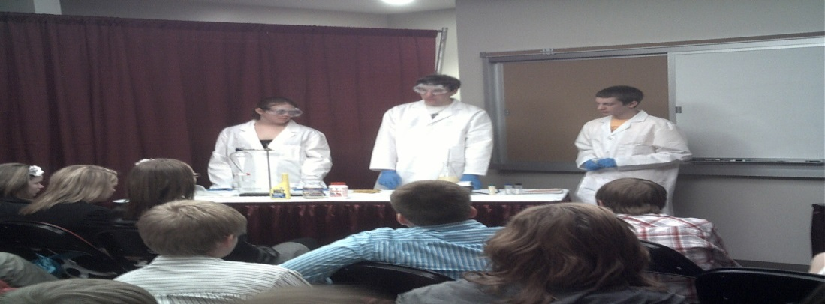
Figure 2: The members of BioBus during one of the outreach activities

ENGINEERING MEETING

Job description (current officer)

Ryan Schwenker - Director of Engineering
Dustin Monat - Vice President of Engineering

What is BioBus Engineering?
- Managing lab space
- Securing chemicals
- Managing machinery
- Acquiring oil
- Organizing the processing of fuel
- Supplying Cyride with finished fuel

Safety in the Lab
Processing must be done between the hours of 8am to 5pm Monday through Friday. Two students must be present in the lab when working with or on the processor, and one must be a grad student. To enter the lab, members must provide proof of completion of 3 EH&S online safety trainings. The trainings can be found here (website) and include:

- Lab safety fundamentals
- Fire extinguisher training
- Management of unwanted materials
- Details on where to go in the lab for certain catastrophic events
- Members must also adhere to the PPE requirements in the lab.

To enter the lab, you will need to follow the lab dress code:
-Shoes that completely cover the foot.
-Pants that completely cover the legs. No shorts, dresses, or short-cut pants.
-If you have long hair, please be prepared to tie it back while working.
-We’ll provide you with a lab coat goggles, and gloves to be worn while working.
-No food or drinks are allowed inside the laboratory.

Before processing, be sure to acquire the proper amounts of all chemicals to complete the reaction.
Given below is estimation of the required chemicals:
8 gal Methanol – the amount of methanol needed is 20% from the total vegetable oil in the tank
40 gal Vegetable Oil – amount of oil that usually used for one batch of reaction
X grams KOH/NaOH - amount of KOH/NaOH needed is known from the titration. *more in SOP
(+titration materials)
Before starting the processor, examine fittings and hoses to ensure there are no leaks or loose components. Check clear tube on side especially!

Material needed:
Material Needed | Source | Payment Method
Raw material  (used veggie oil) | UDCC | FREE
Chemical input | Chem Store | Engineering Account
Lab equipment | Various local store | P-Card

Structure of Engineering Meetings
The engineering meeting also takes place once a week. The process to produce the biodiesel is as follow:

- Oil Collection.
BioBus collects used veggie oil from the UDCC, a few blocks from our lab. BioBus uses a machine called The Super Sucker as shown in Figure 3. This machine is a wheeled 60 gallon tank with an air pump, fittings, and a battery. The Super Sucker also has a small spill-containment kit attached. This kit includes paper towels, extra gloves, and enough clay kitty litter to manage a small spill.

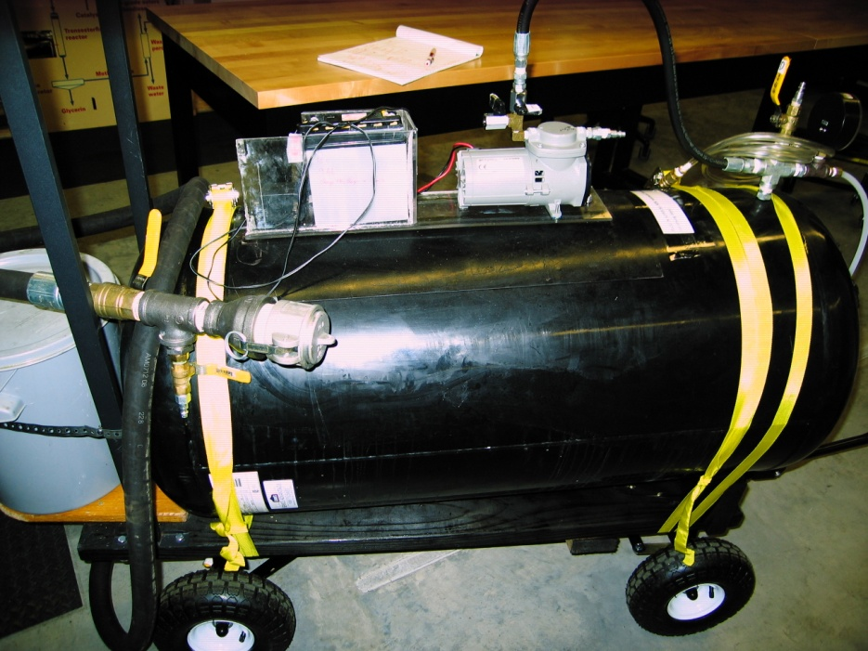
Figure 3: The picture of The Super Sucker that is used to collect veggie oil from UDCC

- Transferring and Drying the Oil.
Oil from The Super Sucker is pumped into the processor using compressed air and the processor’s pump. Oil is then circulated, with the lid off and the heater on, to reduce water content in the oil. Water content can be tested with the splatter test, and/or reducing the oil temperature, and observing clarity. The drier the oil at the beginning, the better quality of finished fuel, with less soap produced.
Remember to turn on the heater after turning on the pump or else you might short the heater!
- Reaction Process
Titration
-Titration is performed to determine the amount of catalyst needed for the trans-esterification.
Reaction
-Methanol is added into the methanol mixing tank. The Methanol pump is turned on to circulate and dissolve the mixture. To ensure the catalyst dissolves perfectly, the amount of catalyst needed is added slowly into the mixing tank in smaller quantities one at a time. The next unit is added after one unit dissolves completely. The methanol pump is turned off after all the catalyst has been dissolved in the methanol mixture.
-The mixture containing methanol and catalyst is transferred into the processor tank for the reaction to begin. The content is then left to allow the reaction to take place.

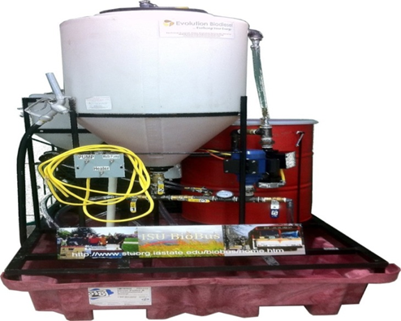
Figure 4: The picture of the processor for the reaction takes place
- Draining Glycerol
As the reaction goes to completion, two layers of product can be seen. Glycerol will be at the bottom, while the biodiesel is at the top. The glycerol is drained out of the tank into a container to separate it from the desired product, biodiesel. The container is labeled with the complete name and date according to EH&S requirements and is put into secondary containment to be collected by EH&S and be discarded.
If the reaction takes place completely, the amount of glycerol drained out should be the amount of methanol added.

- Washing Biodiesel
The biodiesel is washed to remove excess catalyst, methanol and impurities. It is washed using pure water. A water hose from the wall is attached to the nozzle of the processor tank lid. The tap is adjusted to get a very fine mist. If the spray is too harsh the reaction will make soap. Since oil is less dense than water the water flows through the oil to the bottom of the processor. The water which is at the bottom layer is drained once approximately 5 gallons has been added.
The process is repeated simultaneously until the amount of water used to wash is slightly the same as the amount of biodiesel, which is approximately 40 gallons.

- Drying The Biodiesel
Again, the oil is circulated, with the lid off and the heater on, to reduce water content. This can take up to 4 hours, and the clarity of final product is checked once the drying process is over. After drying the process is completed, and the fuel is ready to be transferred to Cyride.

*The drying process is usually done outside the club meeting time since this process takes the longest amount of time.

As time permits, the whole process is repeated to produce more batches of the biodiesel in the current semester.

FUTURE PLANS

- Drying through electrolysis
- Trans-esterification through ultrasonic means
- Dry wash system
-Increase production capacity

DIRECTORY OF IMPORTANT CONTACT

Adviser:
Dr. Thomas J. Brumm,
Associate Professor
Department of Agricultural & Biosystems Engineering

Office:
1328 Howe Hall
Ames, IA 50011-2274
515-294-5145
tbrumm@iastate.edu

Other info
Website:
http://www.stuorg.iastate.edu/biobus/index2.html
Facebook:
https://www.facebook.com/ISUBioBus?fref=ts
Twitter:
@isu_biobus

APPENDIX

Tenancy Agreement between the Biorenewables Research Laboratory (BRL) Building and ISU BioBus
Center of Sustainable & Environmental Technologies – ISU

Written by
David Correll (ISU BioBus) Date: 8th March 2011
Reviewed and amended by
Jacqulyn Baughman and Ryan Smith (BRL), David Correll, Bernardo Del Campo and Thomas Brumm (ISU BioBus)

Project Description
ISU BioBus is a student-run organization that seeks to recycle waste vegetable grease from ISU campus dining facilities into biodiesel fuel for our university's CyRide buses. ISU BioBus intends to use space in the BRL laboratory for: (1) housing and utilizing our biodiesel processing equipment and materials; (2) pre-processing vegetable oil and testing the quality of finished biodiesel; (3) staging demonstration sessions and public outreach; and (4) holding project-related group meetings.
Privileges and Responsibilities
ISU BioBus and the BRL building administrators agree to the following privileges and responsibilities arising from ISU BioBus’ tenancy in the BRL building:
(1) ISU BioBus Student Group Responsibilities
- 1a) Maintain a clean, safe and tidy laboratory space, subject to inspection at any time by BRL staff.

- 1b) Maintain full compliance with ISU Environmental Health and Safety regulations and BRL requirements at all times. These requirements include, but are not limited to,:
  - There must be at least two ISU BioBus personnel in the lab when doing tasks/work pertaining to the Biodiesel processor AT ALL TIMES. No ISU BioBus personnel are to work alone in the lab.
  - Prior to any processor tasks being performed, ALL personnel involved in the tasks MUST have completed the 3 Core E, H & S safety courses, and a copy must be provided to Jacqulyn A. Baughman for record-keeping. A copy must also be retained by ISU BioBus.

Lab Safety: Fundamental Concepts | Once
Management of Unwanted Materials for Laboratory Personnel | Annually
Fire Safety and Extinguisher Training  (Recommended at least once for hands-on practice.) | Annually

  - Any additional safety or other training required by BRL administration will be communicated to ISU BioBus personnel on an as needed basis.

- 1c) Coordinate with BRL staff to schedule and coordinate demonstrations of biodiesel production and/or testing, at the request of Jacqulyn Baughman and/or Dr. Robert Brown, with at least one-week advanced notice.

- 1d) Install (but not necessarily purchase) ISU BioBus equipment, including but not limited to the biodiesel processor, the flammables cabinet and the computer system in the laboratory space.

- 1e) Remove all equipment owned by the group from the BRL laboratory upon termination or relocation of the ISU BioBus project for any reason.

- 1f) Coordinate the use of the laboratory space between ISU BioBus and BRL administration, understanding that BRL lab activities take priority in lab space use in 1115. There may be times when BioBus will be asked to re-arrange production times when lab activities are taking place in 1115.
- 1g) Keep a current copy of the processor SOP and all MSDS sheets, accessible at all times, in the lab.
(2) ISU BioBus Student Group Privileges in the BRL Laboratory and Building
2a) The defined laboratory space shall be room 1115 BRL. Activities would be intended to be performed during regular business hours (8- 5pm Monday – Friday), members of the ISU BioBus student group, subject to clauses 1b and 1c above, may , base on coordination with BRL Administration :
    - Use and access of ISU BioBus equipment, reactants and products during processing
    - Use BRL equipment upon approval from BRL Administration
    - Store chemicals needed for production, testing and cleaning.
Store up to 55 gallons of waste vegetable oil and 55 gallons of biodiesel in secondary spill containment.
    - Store and use paperwork records, personal protective equipment and cleaning supplies in BRL approved locations in the 1115 lab

2b) Within 1115 BRL, ISU BioBus has the privileges to:
2d i) Process up to 55-gallon batches of vegetable oil into fuel, per the safety requirements of EH&S and BRL administrators.
2d ii) Conduct group meetings unless BRL activities require utilization of the lab space.
2c) 3 keys to the laboratory and entrance access to the BRL building will be provided to ISU BioBus. These keys will be given to the Club President; Vice President, and Faculty Advisor. These three key-holders may convene group meetings or processing runs in 1115 BRL outside of standard BRL building hours. For example: such instances may include, but are not limited to, (1) starting processing runs prior to 8am on weekdays; (2) ISU BioBus’ regularly scheduled group meetings, which typically convene from 5 to 7pm on Fridays; and (3) preparation for outreach events like VEISHA and the City of Ames Eco-Fair, which can fall on weekends or require early-morning or night-before preparation.
2d) ISU BioBus’ equipment and materials are not to be moved or used without prior notification and consent of ISU BioBus leadership.
2e) ISU BioBus’ privileges inside the BRL building are restricted to 1115 BRL.
3) BRL Responsibilities
3a) To provide 3 sets of keys for the laboratory and the front building doors for club officers as listed above in clause 2c.
3b) To, in good faith, coordinate BRL’s other responsibilities with ISU BioBus’ plans to engage in weekly batch production of biodiesel fuel and other project-related activities.
4) BRL Privileges
4a) BRL Administration can request that ISU BioBus stage a demonstration in the lab for the BRL’s educational and outreach initiatives. Such requests should come, at least, one week in advance to ISU BioBus student leadership. Such requests will be negotiated based on time and availability of BioBus personnel.
4b) BRL reserves the right to inspect the ISU BioBus laboratory, its equipment and its contents at all times during the tenancy. This does not include unauthorized use or relocation of ISU BioBus’ equipment and materials. (See 2a)
4c) BRL reserves the right to terminate the ISU BioBus’ tenancy in the BRL building at any time.

ISU BioBus Project Plans and Funding/Partnership Disclosure:
ISU BioBus enjoys several other important partnerships, whose interests we must also preserve while working with the BRL building.
In conjunction with a financial grant received from the ISU College of Business, we will become a learning laboratory for undergraduate business classes. The exact nature of that involvement has yet to be defined.
In conjunction with a financial grant from the ISU Pappajohn Center for Entrepreneurship/The Coleman Foundation, we will make education and outreach about biorenewable fuels and entrepreneurship a core part of our mission, which will entail demonstrations inside and outside of the BRL laboratory site.
CyRide has agreed to utilize the biodiesel that ISU BioBus produce and ISU Dining has agreed to supply us with waste grease from the UDCC dining complex. In conjunction with ISU Environmental Health & Safety (EH&S), ISU BioBus has the following plan:
Phase 1 Production: March 2011 – May 2011
The collection of roughly 5 gallons per week from the UDCC and convert it to biodiesel for CyRide, free of charge. EH&S will handle transportation of both waste grease and biodiesel across campus and into 1115 BRL. At this testing scale, we will not apply for a fuel sales license with the Iowa Dept. of Revenue. We will collect the grease; ISU EH&S will deliver the grease to 1115 BRL; ISU BioBus will process the grease; and ISU EH&S will deliver the finished product to CyRide. Tentatively, we anticipate once weekly small-batch production (probably on Wednesdays) as well as weekly group meetings on Friday evenings as well as associated testing, tinkering and preparation work in the laboratory space.
Phase 2 Production: May 2011 – August 2011
Processing quantity moves gradually up to roughly 50 gallons per week and ISU BioBus assumes sole responsibility for transportation and logistics of waste grease and biodiesel fuel. Before this phase begins, we will obtain a fuel sales license and arrange to pay road use taxes with the Iowa Dept of Revenue. (Note: This discussion has already begun and the Iowa Dept. of Revenue is apprised of our plans and willing to help when we get to Phase 2.)
The signatories below agree to abide by the above clauses to the best of their abilities and to rectify any discrepancies through consultation among BRL and ISU BioBus leadership. The “Tenancy Agreement between the Biorenewables Research Laboratory (BRL) Building and ISU BioBus” could be reviewed and modified at any time in agreement to both parties:
BRL Building Administration

Dr. Robert Brown ______________________ Date: ________________________________

Jacqulyn Baughman ______________________ Date: ________________________________

ISU BioBus

David Correll____________________________ Date: ________________________________
(ISU BioBus President)

Bernardo Del Campo______________________ Date: ________________________________
(ISU BioBus Vice President)

Dr. Thom Brumm_________________________ Date: ________________________________
(ISU BioBus Faculty Advisor)

